**eBalance-Kit Management test report**

# Scope

The purpose of this test report is to test the eBalance-Kit Management logging tool.

# Related Documents

**Title** **Version**

-

# Test Equipment

The test equipment used eBalance-Kit test:

* eBalanceKit version 1.6
* eBalanceKit Management
* SQLite database local instance

# Test Results

## Summary

Most of the actions were logged correctly, except few ones, mostly comment changes weren’t. Sometimes an action logged twice, and in the Reconciliations section the eBalanceKit crashes during few actions. Error screenshots attached to this document in section 4.7. Error screenshots.

## Passing Tests

All test results are documented in attached XLS document.

## Test Failures

All test results are documented in attached XLS document.

## Deviations from Planned Testing

-

## Defects / Problem Reports

All test results are documented in attached XLS document.

The eBalance Kit crashed with exception at two times.

Reclassification: If there is no assigned value to the “destination of reclassification” or to “position which should be reclassified”, and try to remove it, the application crashes with an unhandled exception. See ***error4*** image in section *4.7 Error screenshots*.

Imported values: Export crashes with an unhandled exception. . See ***error5*** image in section *4.6 Error screenshots*.

## Quality Assessment

-The unhandled exceptions need to be fixed.

-The eBalanceKit Management tool should be able to filter for the columns of Time, User, Event.

-In the eBalanceKit Management tool if the user try to export logs, and pushes Cancel, the export file will be created any way.

## Additional Informations

-

## Error screenshots

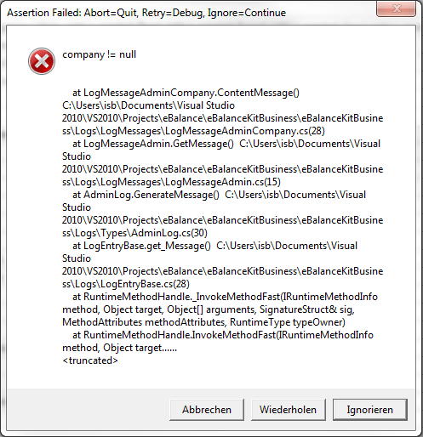

*Error 1*

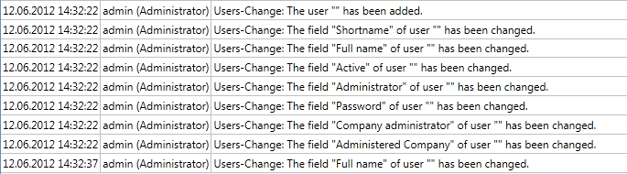

*Error 2*



*Error 3*

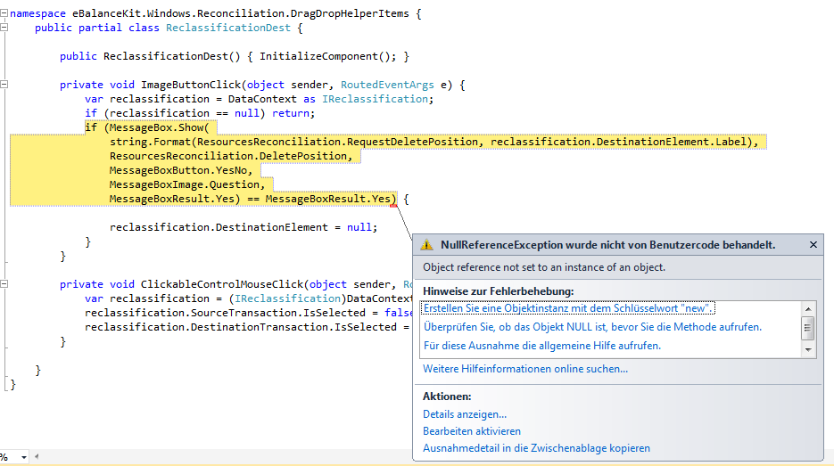

*Error 4*

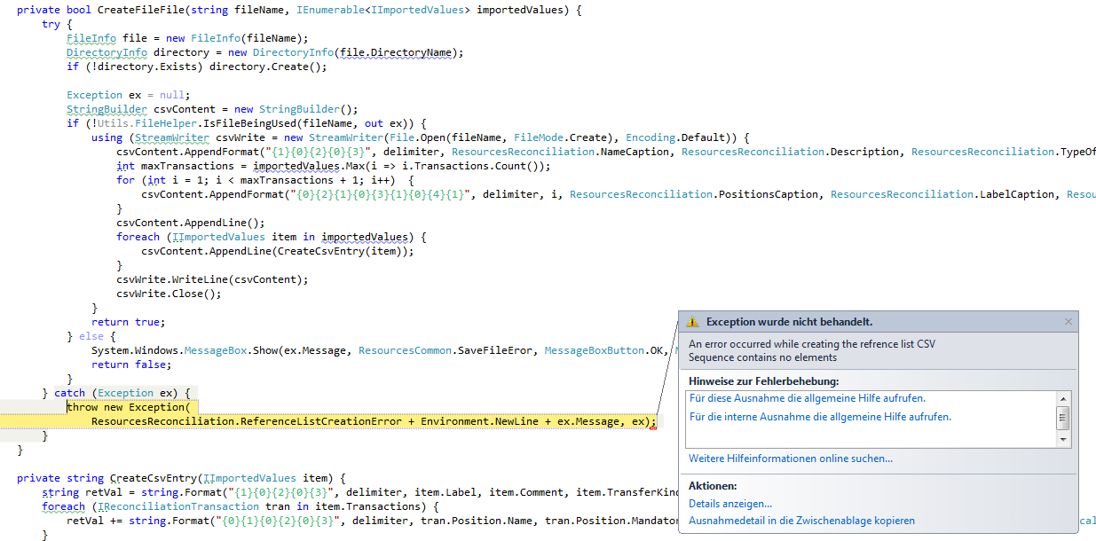

*Error 5*

C:\Users\isb\Desktop\error7.png

*Error6*